2a. Write a python code to create nested tuples.
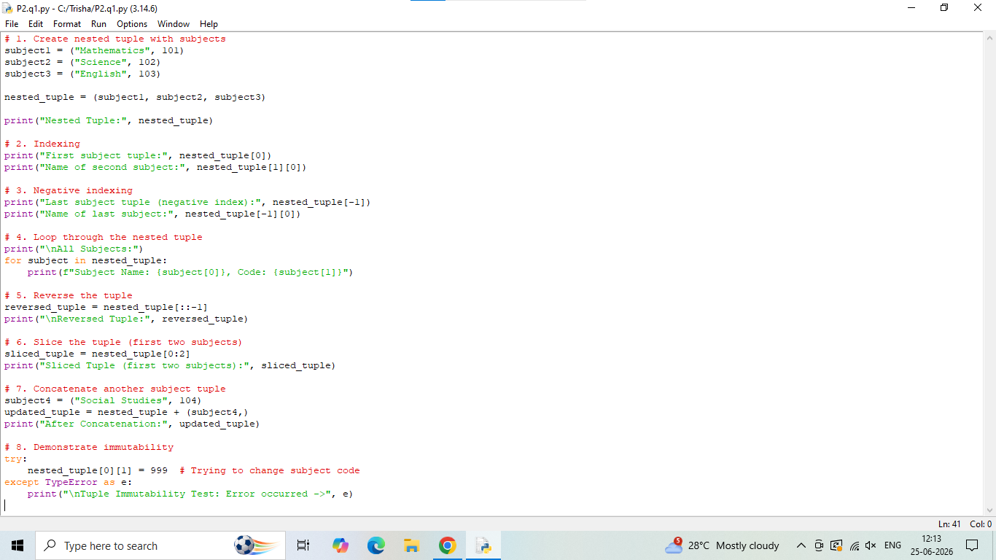
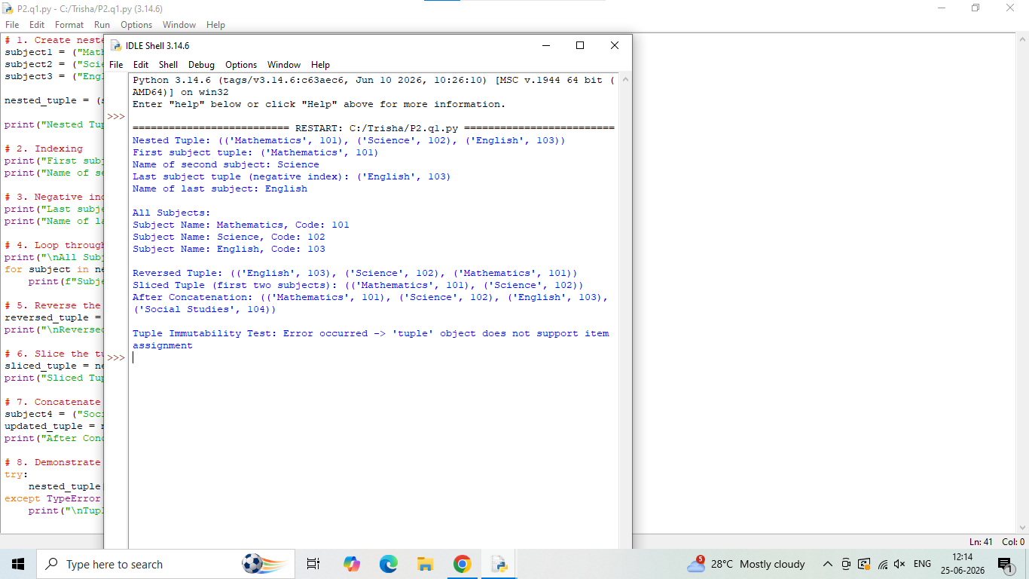

2b. Write a python code to sort the nested tuple using sorted() function.
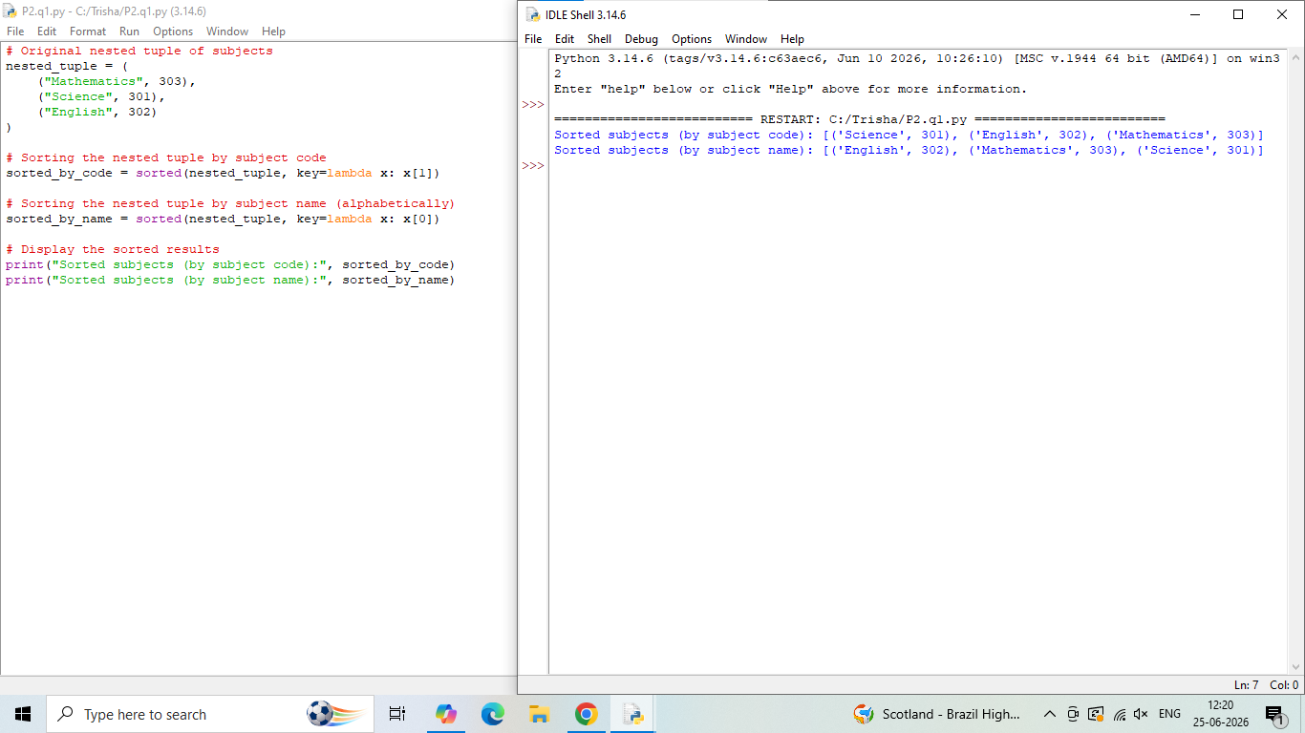
2c. Write a python code to copy or clone list.
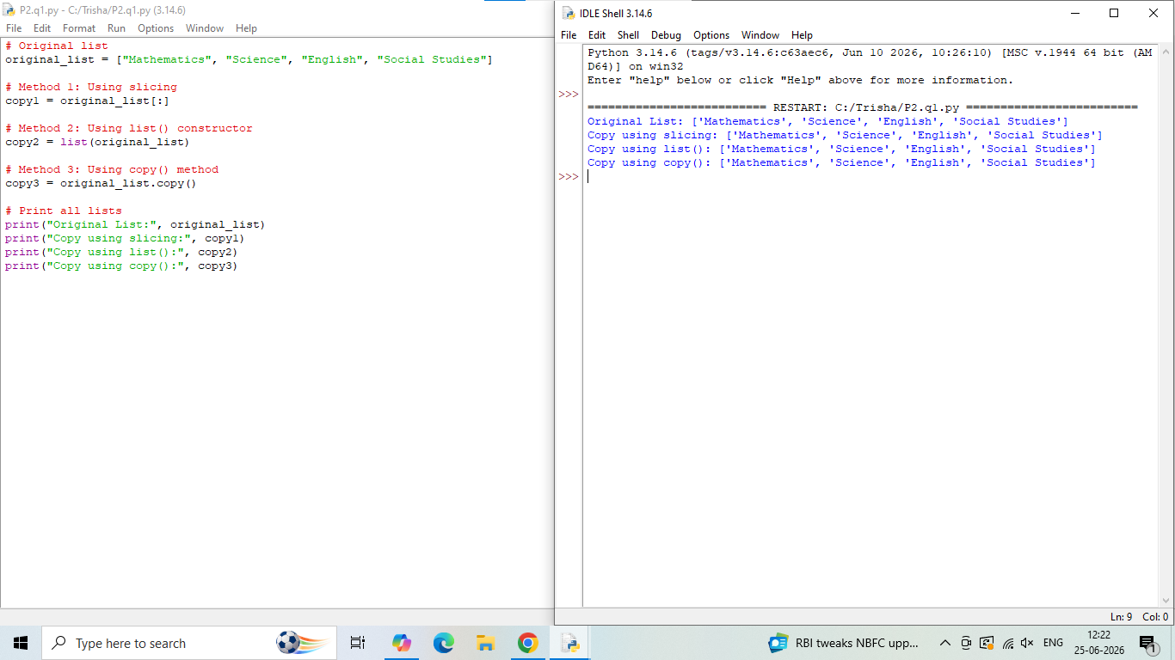

2d.Write a python code to check immutability property of python tuples.
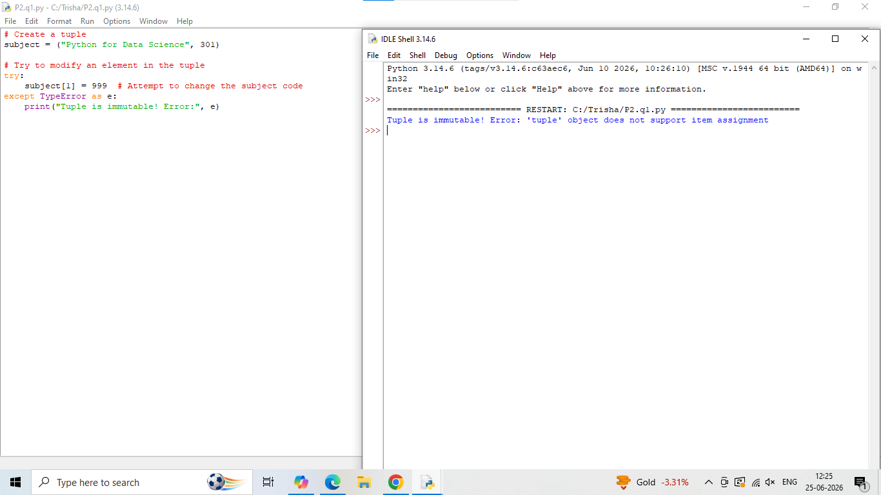
Question 1: [Implement the below given questions in a single python file]
a. Write a Python program to create a tuple with 5 different elements and print it.
b. Write a program to access the first and last elements of a tuple using indexing.
c. Write a program to slice a tuple and print the middle 3 elements.
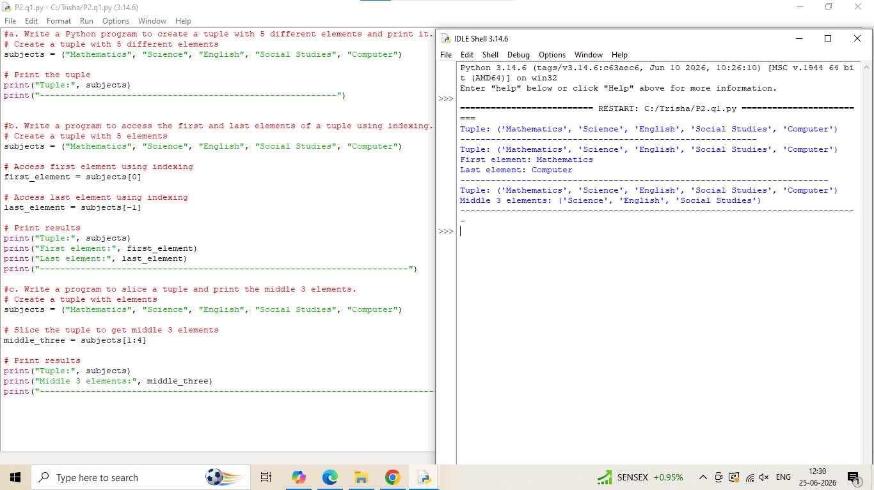
d. Write a program to concatenate two tuples and print the result.
e. Write a program to reverse a tuple using slicing.
f. Write a program to count how many times an element appears in a tuple.
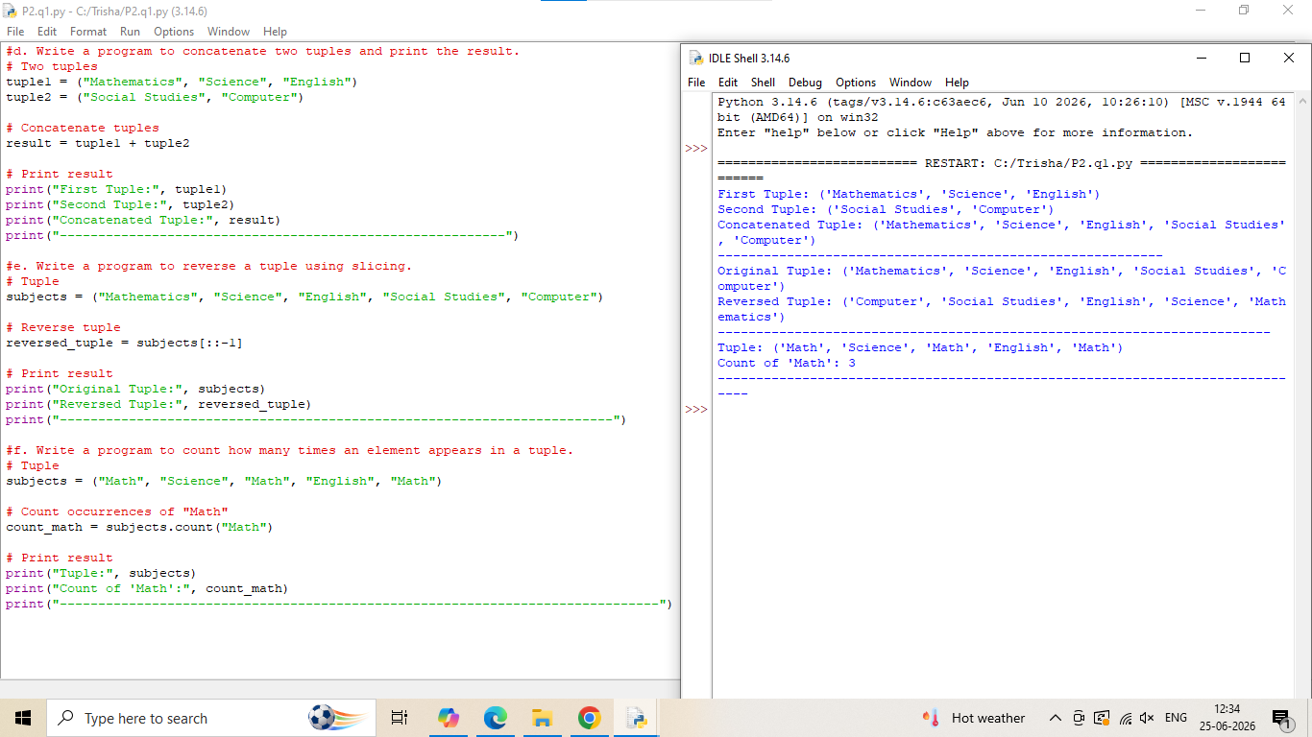
g. Write a program to find the index of a specific element in a tuple.
h. Write a program to check if an element exists in a tuple.
i. Write a program to convert a list to a tuple.
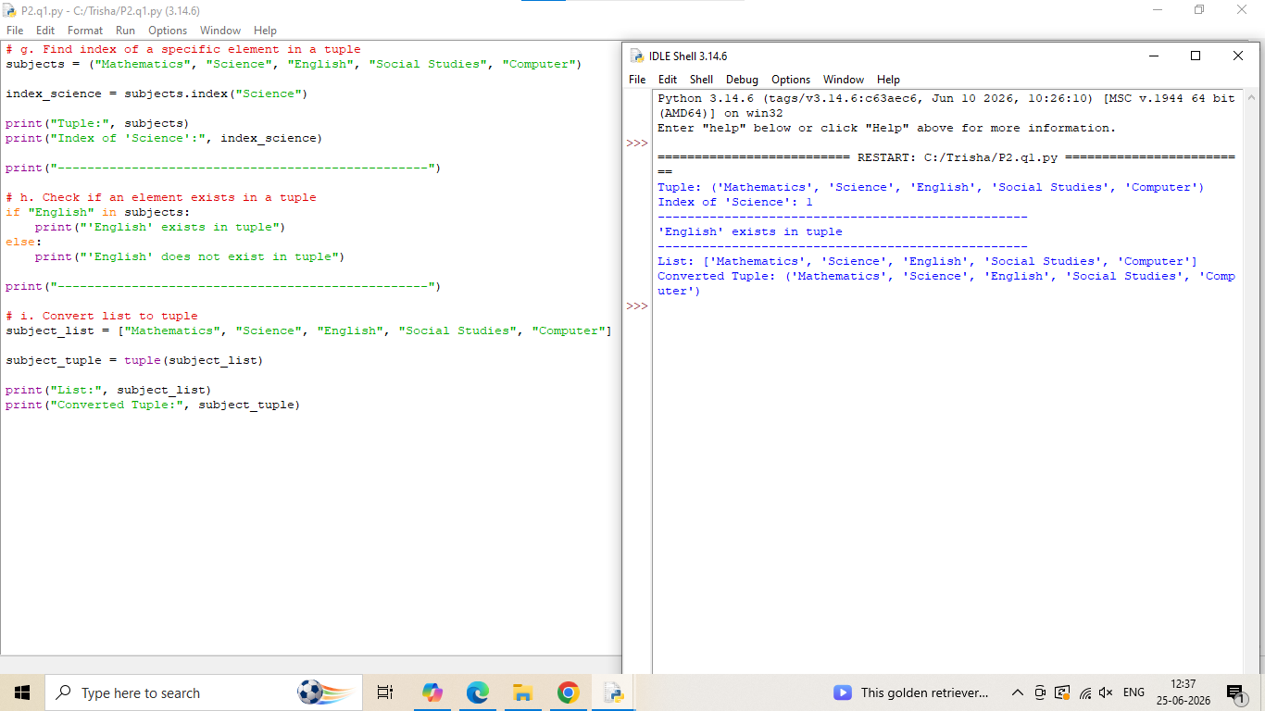
j. Write a program to sort a tuple of numbers in ascending order.
k. Write a program to repeat a tuple 3 times using the * operator.
l. Write a program to check the immutability property of tuples by trying to modify an
element.
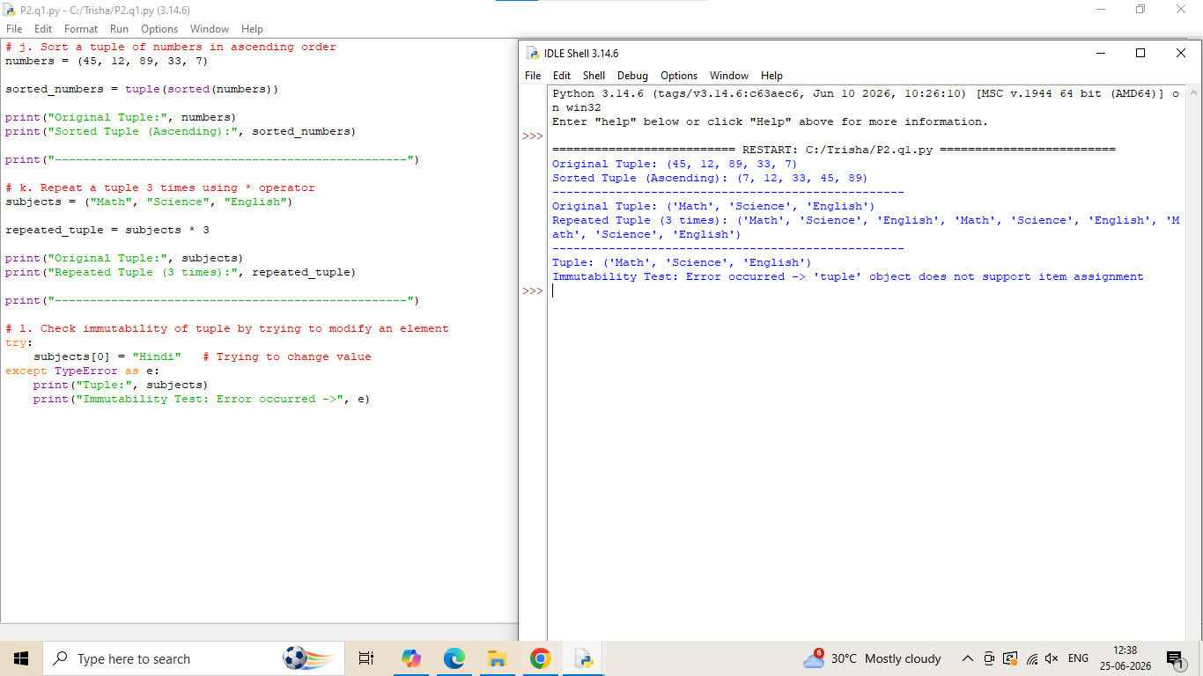
Question 2: [Implement the below given questions in a single python file]
a. Write a program to find the largest number in a list.
b. Write a program to remove duplicates from a list.
c. Write a program to count how many even numbers are in a list.
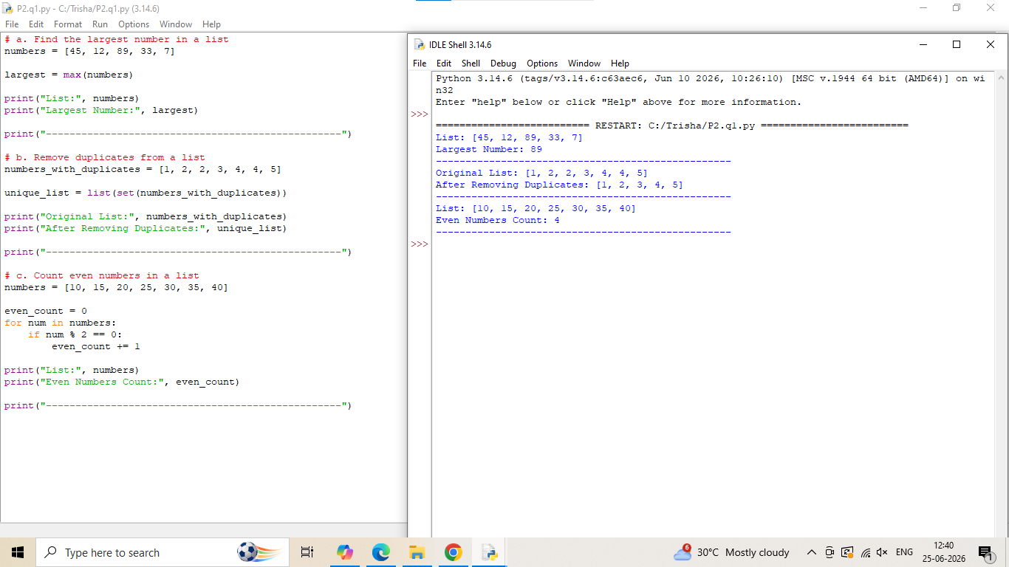

d. Write a program to input 5 numbers and store them in a list. Then display the list.
e. Write a function that returns the average of all numbers in a list.
f. Convert a string into a list of characters using list().
g. Join all elements of a list into a single string using join().
